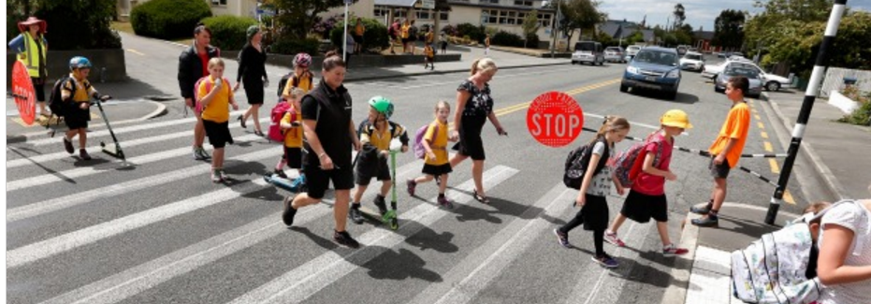

The Walking & Cycling Community Innovation Fund

Table of Contents

Introduction 2
Criteria 2
Exclusions 2
Who Can Apply? 3
Application form 4

Introduction
MOVEMENT is a charitable Trust with the key objective of improved walking & cycling in urban NZ. One strategy to achieving this is to facilitate innovative projects by the community.

Applications open each year in March and close end of November. Applications of up to $10,000 are invited.
Criteria
Criteria for grants to the Walking & Cycling Community Innovation Fund are:

- Showing innovation in giving effect to our objective of “improved walking & cycling in urban NZ”:
  - safe space for walking & cycling
  - safe traffic speeds: eg 30 km/h urban streets and 60 km/h rural roads where people are walking & cycling on the road.
  - more investment in walking & cycling
  - greater numbers of people walking and cycling

- How much impact is expected by the innovation?
- enduring benefit
- bike/walk community capacity building,
- community participation,
- street safety solutions,
- public awareness,
- behaviour change initiatives,
- specific campaigns to enhance walking & cycling.

- Degree of matched funding from other sources

Exclusions
Not for physical infrastructure unless attempts have been made to get Council / NZTA to fund.

Who Can Apply?

Single organisations or coalitions may apply to this fund, with at least one organisation having a charitable purpose:
- Iwi or mana whenua
- Charitable organisations or incorporated societies
- Schools
- Social enterprises
- Individuals

Application form
Please advise the following and send your application to andy@movement.org.nz

Any questions re the Walking & Cycling Community Innovation Fund to bevan@movement.org.nz

- Project name

- Name of entity and legal status of applicant. Contact details.
- Project summary
- Total cost of project and amount requested from the Walking & Cycling Community Innovation Fund as follows

Nature of expense | Amount applied for | Match funding ($ & who from)
Totals: | $ | $

- Alignment with the 3 criteria above
  - Showing innovation in giving effect to our objective of “improved walking & cycling in urban NZ”
  - How much impact is expected by the innovation?
  - Degree of matched funding
- Evidence of cooperation with community/stakeholder groups. Please advise what level of consultation has been carried out.

- Required documents:
  - Recent financials (income statement and balance sheet)
  - Project budget and quotes
  - Project Plan

Applicants are encouraged not to apply for 100% of funding from Trust, ie: we prefer to be one of at least two funders.

Examples of areas funded could include – community walking and/or cycling festivals, advocacy for specific campaigns, wages and administration, design & production costs, venue hire, cycle training, walking and cycle mapping, and tactical urbanism / community led initiatives

